**Question 1**

1.Draw a conceptual schema for the specification of the database domain listed above. Use the UML simplified class diagrams explained during this subject. Note: you are not allowed to use any artificial identifiers (create new IDs) and or add any attributes that are not explicitly mentioned in the specification.

Answer 1.

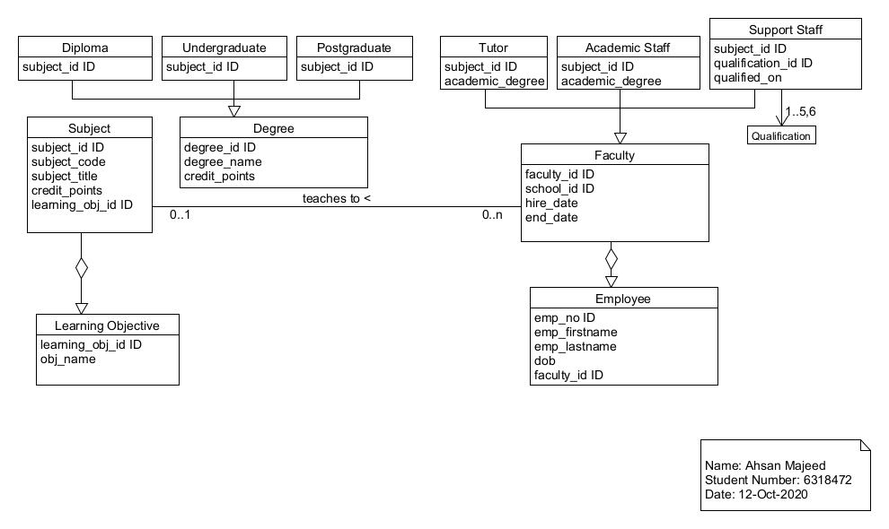

***Figure 1. ER Diagram of University Management***

2.Add two (2) new object classes with at least five (5) attributes each and appropriate associations. The choice of object classes, attributes and associations are up to you; however, these should relate to the existing scenario.

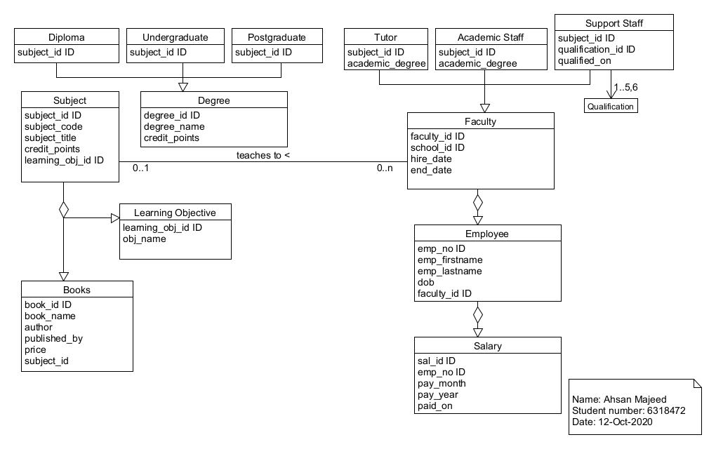

***Figure 2. Updated ER diagram of University Management***